Experiment-13
Write A Python Program To Implement Minimax Algorithm For Gaming
Aim
To write and execute a Python program to implement the Minimax Algorithm for the Tic-Tac-Toe game, enabling the computer to select the best possible move.
Algorithm
- Start the program.
- Initialize a 3 × 3 game board with empty spaces.
- Assign X to the human player and O to the computer.
- Display the game board.
- Get the human player's move.
- Check whether the move is valid and update the board.
- Check whether the human player has won or the game is a draw.
- Generate all possible moves for the computer.
- Apply the Minimax algorithm to evaluate each possible move.
- Select the move with the highest score for the computer.
- Repeat the process until a player wins or the game ends in a draw.
- Display the final result and stop the program.
Code
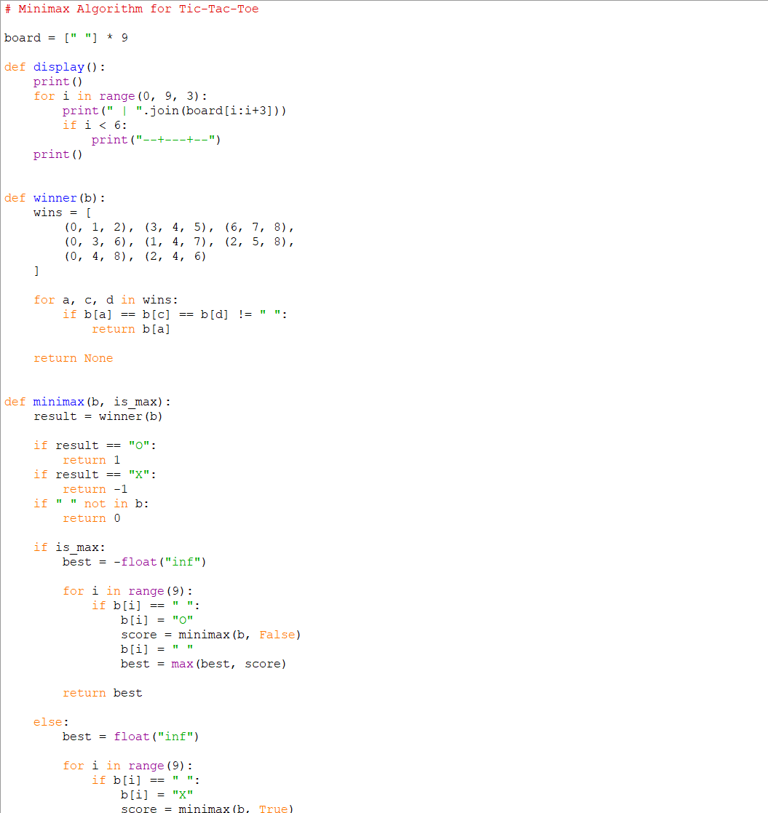
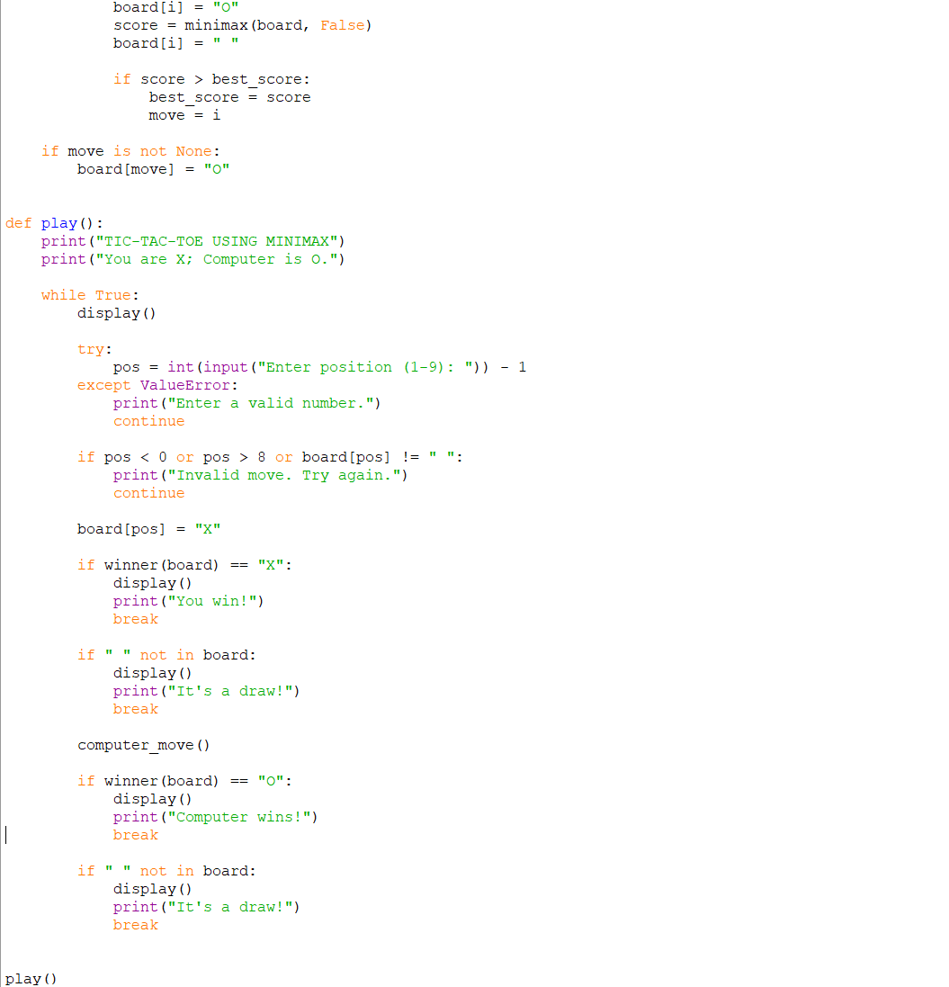
Output
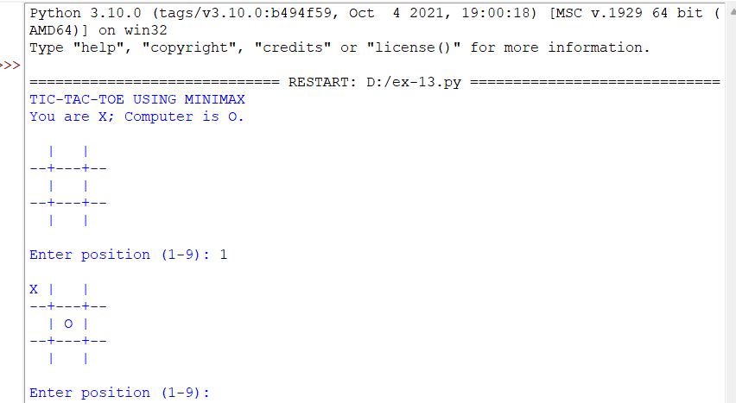
Result
The Minimax Algorithm was successfully implemented for the Tic-Tac-Toe game. The computer evaluates possible moves and selects the best move to maximize its chances of winning or achieving a draw.

